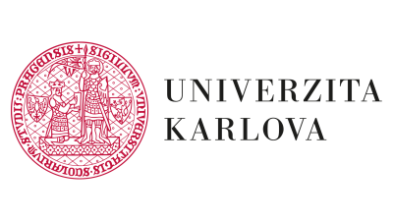  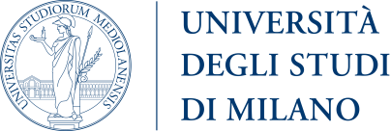  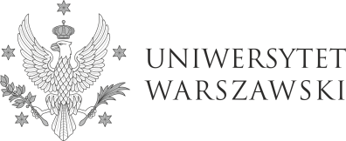 | 4EU+ Course  „Urban Regulations and Political Memory: Towards Understanding  Spatio-Temporal Aspects of Urban Development”  (UNREAD)  Information for students  „Urban Regulations and Political Memory: Towards Understanding Spatio-Temporal Aspects of Urban Development” is an international, interdisciplinary course organised by three 4EU+ member universities: University of Warsaw, University of Milan, Charles University, as part of the 4EU+ joint educational offer during the academic year 2022/2023.  Key topics of the course are the driving forces of urban changes, the development of smart cities and interdisciplinary methodologies of urban studies. The course is developed as part of an educational project which addresses changes in the conditions of the urban development of smart cities in Poland, Italy and Czechia, according to three dimensions: past (history), present (law) and future (geography). Emphasis is put on integrated and interdisciplinary approach in order to help students understand the complexity of new urban centers in which real estate development must coexist with the protection of the environment and with the history and heritage of the local community.  The course will be conducted by an interdisciplinary team of historians, lawyers and geographers.  Course dates: Wednesdays’ afternoons, starting from 5th October (13:15-14:45 / 13:15-15:45 / 13:15-16:30).  Language of instruction: English.  Number of online didactic hours: 30 (18 hours of lectures, 12 hours of workshops).  Assessment methods and conditions for obtaining credit: Group work: producing an essay and delivering a presentation (each student group has to comprise participants from different universities). Essays will be presented at a face-to-face or online (to be confirmed) conference (2 days) held at the Charles University in Prague in April 2022.  ECTS credits at Charles University: Faculty of Law 4, Faculty of Science 5. / ECTS credits at University of Milan: 3. (University of Milan: history –only MA students). / ECTS credits at University of Warsaw: Faculty of Law 6, Faculty of History 4.  Application and selection:  The students will be selected based on their CV and motivation letter. The deadline for sending the documents is 25th September, 2022. The CV and the motivation letter should be sent as a single PDF document to unread@wpia.uw.edu.pl. The file's name should contain the applicant's name (surname_name.pdf), and the subject of the email should be "UNREAD recruitment”. The motivation letter should indicate the students’ objectives and motivations for taking the course. The motivation letter should not exceed 1,000 characters.

